Forest Health Highlights Vermont 2021

Forest Insects and Diseases

Asian Longhorned Beetle
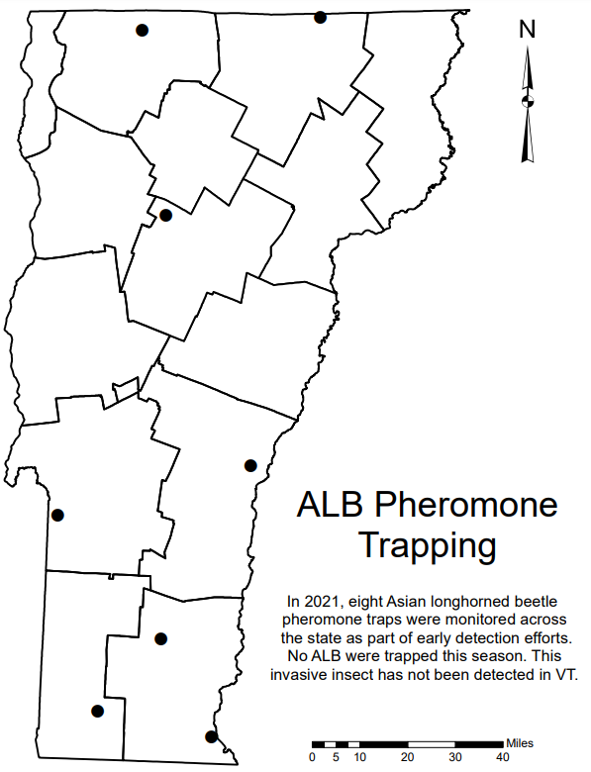
Asian longhorned beetle (ALB, Anoplophora glabripennis) is an invasive wood-boring beetle of a variety of hardwood species including, but not limited to, maples, horse chestnut, willows, American elm, birch and sycamores. This invasive insect has not been detected in VT. As part of early detection efforts, eight ALB combination pheromone traps were deployed statewide in mid-summer (Figure 1). No ALB were trapped this season.

Figure 1. Locations of ALB pheromone traps in Vermont in 2021.

Beech Leaf Disease
Eight long-term Beech Leaf Disease monitoring sites were established across Vermont (Figure 2). Beech leaf disease (BLD) affects both American and European beech trees and causes leaf deformation, dieback, and mortality of infested hosts. The causal agent of BLD is an introduced nematode from Japan, Litylenchus crenatae mccannii. This pest can affect all ages and sizes of beech, being most deadly to saplings and understory beech. This pest has currently been reported in 7 states, and Ontario, Canada. The most recent reports are in Maine (2021), Massachusetts (2020), and Rhode Island (2020). This pest has currently not been observed in Vermont.
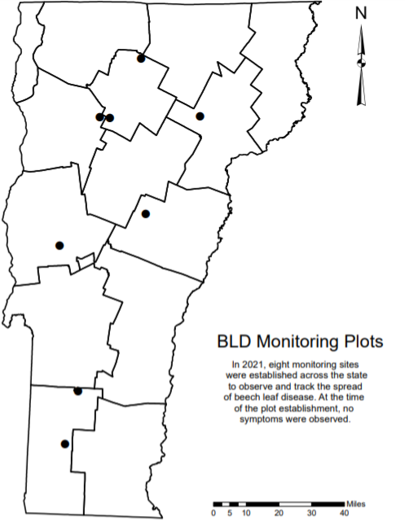
Figure 2. Locations of beech leaf disease (BLD) monitoring plots established in Vermont in 2021.

Emerald Ash Borer
After first detecting emerald ash borer (EAB) in Vermont in 2018, efforts have been made across the state to identify new detections, and to track the spread of the current infestation. In 2021, a total of 110 purple prism traps were established and monitored by a mix of state forestry staff and volunteers (Figure 3). Girdled trap trees were also established by state forestry staff and USDA Forest Service staff on state lands (n = 35) and the Green Mountain National Forest (n =10), respectively. Together with requested site visits, these tools resulted in 30 new detections and 15 new towns with EAB in Vermont in 2021 (Figure 4). New towns include Belvidere, Berlin, Brookfield, Colchester, East Montpelier, Grand Isle, Hartford, Highgate, Middlebury, North Hero, Rupert, Saint Albans Town, Shaftsbury, Vernon and Wilmington. New counties with EAB this year include Lamoille and Windsor counties. Essex county is currently the only county in the state without a confirmed detection.

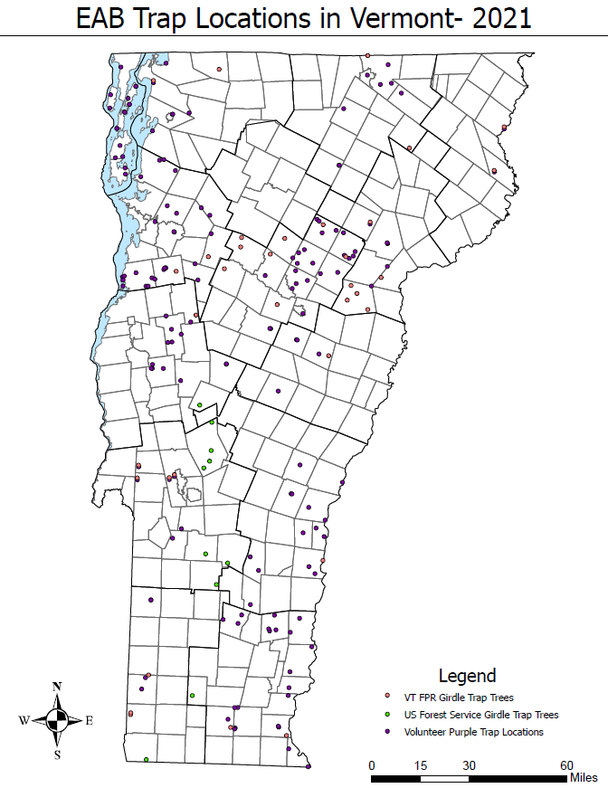
Figure 3. Locations of purple traps and girdled trap trees used for EAB detection throughout Vermont in 2021.
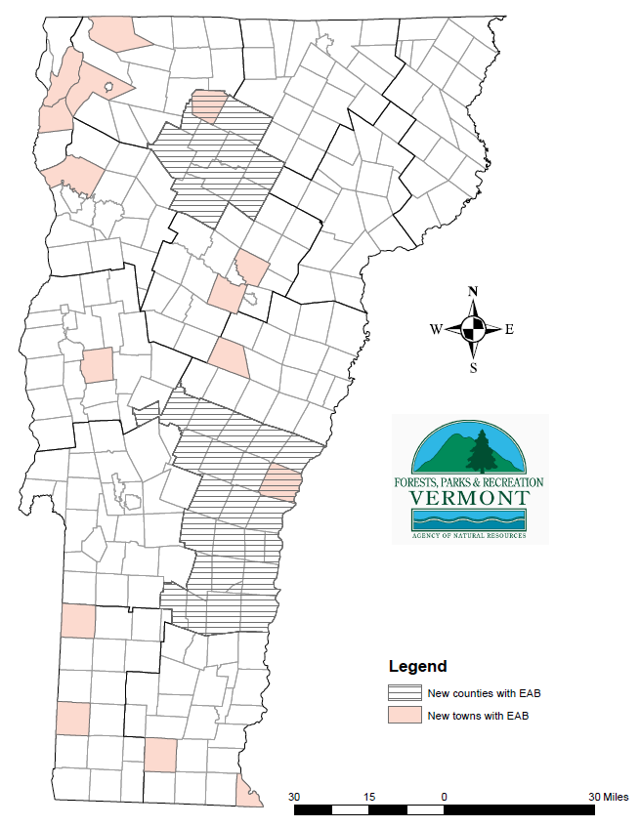
Figure 4. Locations of newly EAB-infested towns and counties of Vermont from 2021.

EAB Biocontrol
EAB biocontrol releases began in 2020 at two sites in Vermont, one at a private campground in South Hero, VT, the other at LR Jones State Forest (Plainfield, VT). The first year of releases included Tetrastichus planipennisi exclusively, with over 4300 wasps released at each site. In 2021, all three parasitoids were available for release, and each site received at least 4000 T. planipennisi, 1100 Spathius galinae, and 1000 Oobius agrili. Recovery efforts will begin in 2022 for T. planipennisi, with another year of releases for both S. galinae and O. agrili. New sites for biocontrol releases in 2022 are being evaluated for suitability and will be submitted to APHIS-PPQ for consideration in the program.

Forest Tent Caterpillar
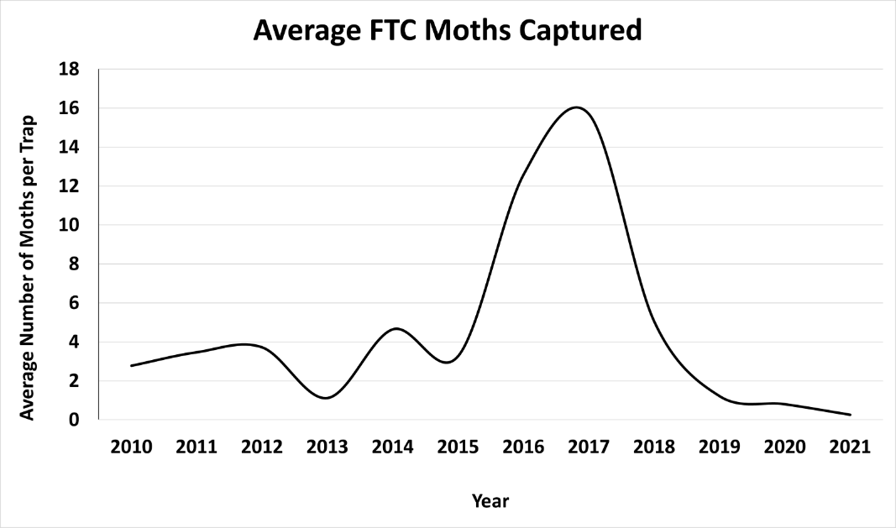
Forest tent caterpillar (FTC, Malacosoma disstria) is a native hardwood defoliator commonly found feeding on sugar maples and ash in mixed hardwood forests. In consecutive years of severe outbreaks, trees may experience complete defoliation which can lead to dieback and mortality of infested hosts. To track population outbreaks, pheromone traps for FTC were deployed statewide in mid-summer. The number of moths per trap averaged 0.25, evidence that populations are continuing to decrease in Vermont following a 2016-2018 outbreak (Figure 5).

Figure 5. Average number of forest tent caterpillar moths caught in pheromone traps 2010-2021. Three multi-pher pheromone traps per site, FTC PheroTech lures, were used in 2021.

LDD Moth
Lymantria dispar dispar (LDD) caterpillar populations grew dramatically this year, resulting in the first outbreak of the insect in Vermont in decades. Reports of defoliation began in northwestern Vermont starting in late May and continued through the end of June. By the end of the feeding period, reports of defoliation were received from all counties in the Lake Champlain valley (i.e., Grand Isle, Franklin, Chittenden, Addison, and Rutland counties). As expected, oak species suffered most of the defoliation, but other hardwoods such as poplar and maple species were affected as well. Caterpillar populations were high enough that non-preferred hosts were targeted in some cases (e.g., spruce, hemlock, pine). In total, LDD feeding resulted in 50,945 acres of damage to Vermont forests in 2021 (Figure 6, Table 1).

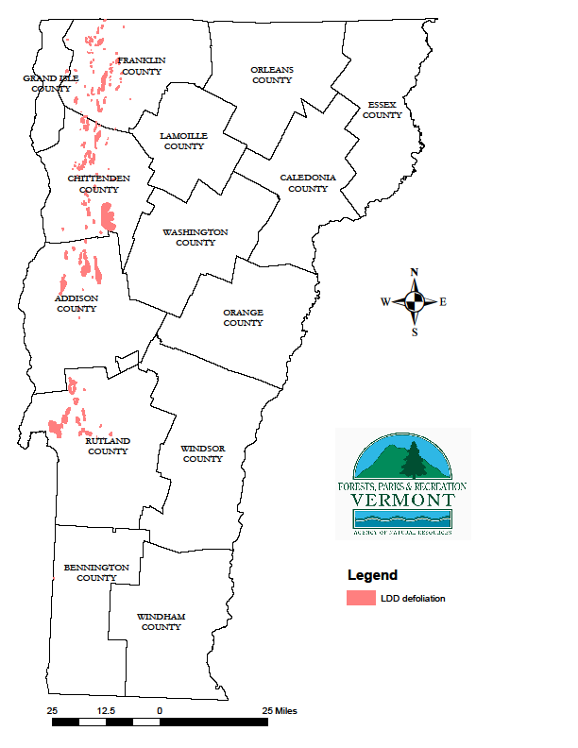
Figure 6. Areas of Lymantria dispar dispar defoliation in Vermont in 2021 mapped during aerial detection surveys. In total, 50,945 acres were affected in the state.
We continue to monitor long-term LDD plots (9) for egg mass abundance and size to inform the public on what to expect in 2022 for defoliation. Additional transect surveys have been added in 2021 to cover a greater geographic extent as well. Available data suggests that we can expect another year of high defoliation in 2022 unless natural enemies and environmental conditions reduce caterpillar survival. Full survey results are expected by the end of 2021 and will be made publicly available.
Table 1. Acres of LDD defoliation by county in 2021.
County | LDD defoliation (acres)
ADDISON | 10579
BENNINGTON | 31
CALEDONIA | 0
CHITTENDEN | 18134
ESSEX | 0
FRANKLIN | 9137
GRAND ISLE | 216
LAMOILLE | 0
ORANGE | 0
ORLEANS | 0
RUTLAND | 12848
WASHINGTON | 0
WINDHAM | 0
WINDSOR | 0
Total | 50945

Hemlock Woolly Adelgid
Hemlock Woolly Adelgid (HWA), Adelges tsugae, continues to threaten hemlock trees in southern Vermont, especially in combination with drought and elongate hemlock scale. Traditionally infested sites are still infested, with no observed spread despite low winter mortality and higher population counts. As of 2021, known infested counties include Windham, Windsor, and Bennington counties.
We continue to maintain five HWA impact monitoring plots. In 2021, monitoring assessments at the Atherton Meadows Wildlife Management Area and Townshend State Park revealed that in general, crowns were smaller and thinner than in previous monitoring. Biocontrol efforts in 2021 used 1500 wildlings of the predatory beetle Laricobius nigrinus, captured from Washington State, and 500 Laricobius nigrinus obtained from the rearing laboratory at Virginia Tech were released at Jamaica State Park this fall. Follow-up monitoring in winter and spring had no recoveries.
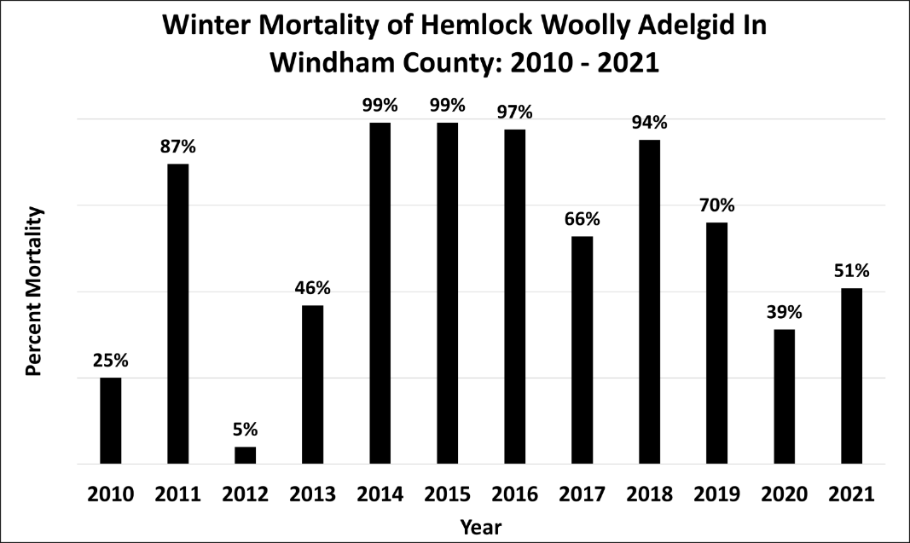
Fifty-one percent of the hemlock woolly adelgids (HWA) examined during the annual winter mortality survey were dead (Figure 7). Although winter temperatures were only slightly colder than last year, in March we experienced periods of warming temperatures followed by successive days of deep freezes. This temperature fluctuation could have contributed to winter mortality by killing otherwise surviving HWA before they could reproduce. In the past, we have often found infestations in new locations following years with mild winters and low levels of HWA mortality. Currently, HWA is primarily found in Windham County, however, it has also been observed in Springfield and Pownal. Similar to past years, Vermont, as well as nearby states, continue to find HWA occasionally mixed with elongate hemlock scale.

Figure 7. Trends in winter mortality of HWA from 2010 to 2021.

Maple Maladies – Maple leafcutter, Saddled prominent, Pear thrips, and Anthracnose
Maple species were impacted by multiple stressors in 2021, including early season defoliation due to pear thrips (Taeniothrips inconsequens), mid-season defoliation from saddled prominent (Heterocampa guttivitta), and late season stress by anthracnose species coupled with defoliation by maple leafcutter (Paraclemensia acerifoliella). In total, 33,939 acres were affected by these stressors, with maple leafcutter accounting for the bulk of these (25,563 acres) (Figure 8). Pear thrips damage was largely detected by aircraft in the southwest corner of the state (4,421 acres) but reports of defoliation came from northern counties as well. Saddled prominent defoliation (2,905 acres) and anthracnose (1,050 acres) were scatted throughout central and southern Vermont.

Maple Leafcutter
Maple leafcutter (MLC) damage is predominately found on sugar maples, although this insect also feeds on other hardwoods such as red maple, beech, and birch species. Larvae excise circular holes in the leaf, which are then bound together with silk, and used as protection from predators and environmental conditions. This defoliation is aesthetically alarming, however, impacts on tree health are low because damage occurs so late in the growing season (Figure 9). This insect caused the most observable damage to hardwoods during late summer and early autumn in 2021, causing our northern hardwood forests to appear brown and discolored before the onset of typical fall colors. Most reports of MLC came from Orange and Washington counties in 2021, though aerial surveys detected considerable defoliation in Caledonia and Orleans counties as well.

.
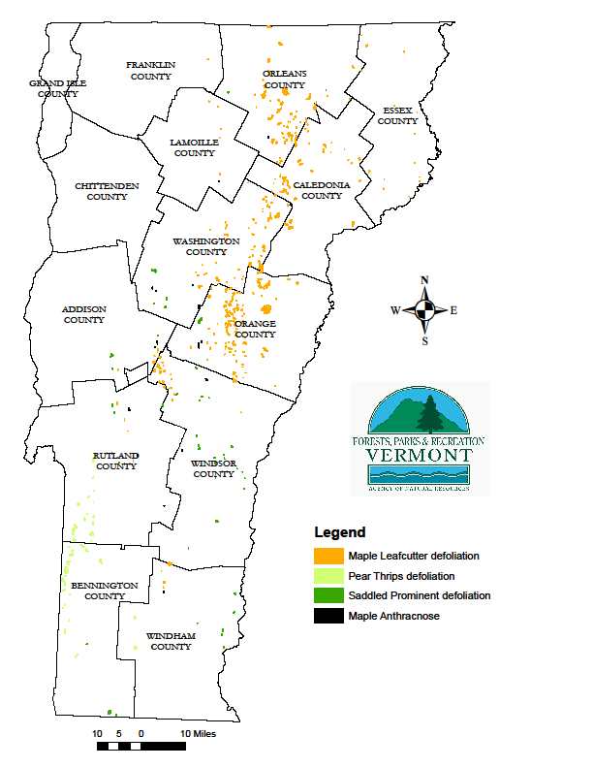

Figure 8. Areas of Vermont affected by maple stressors in 2021 based on aerial detection surveys.

Figure 9. Damage caused by maple leafcutter (MLC) in northeastern Vermont. Image was captured during aerial detection surveys on September 13, 2021. (credit: FPR staff)
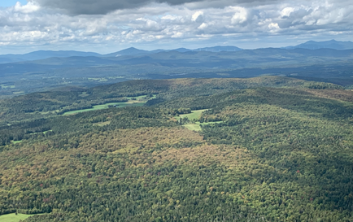

Saddled Prominent
Saddled prominent (SP) are hardwood defoliators native to the northeastern United States. Although a native insect, heavy and repeated defoliation can lead to dieback and mortality of infested hosts. Increased reports of defoliation during the growing season of 2020 led to trapping efforts in 2021. In 2021, reports of defoliation were received from Franklin and Windham counties, but defoliation was recorded via aerial surveys in eight counties (Table 2.).

Table 2. Acres of forest affected by the four most prevalent stressors to maple in 2021.
County | Anthracnose (ac.) | Maple leafcutter (ac.) | Pear Thrips (ac.) | Saddled Prominent (ac.)
ADDISON | 110 | 237 | 0 | 181
BENNINGTON | 0 | 0 | 2262 | 355
CALEDONIA | 0 | 3859 | 0 | 0
CHITTENDEN | 0 | 0 | 0 | 0
ESSEX | 0 | 424 | 0 | 0
FRANKLIN | 0 | 26 | 0 | 0
GRAND ISLE | 0 | 0 | 0 | 0
LAMOILLE | 89 | 96 | 0 | 0
ORANGE | 138 | 9433 | 0 | 344
ORLEANS | 43 | 5489 | 0 | 79
RUTLAND | 243 | 343 | 1750 | 206
WASHINGTON | 253 | 4090 | 0 | 401
WINDHAM | 45 | 494 | 409 | 350
WINDSOR | 129 | 1072 | 0 | 989
Total | 1050 | 25563 | 4421 | 2905

To track population outbreaks, pheromone traps for SP were deployed statewide in late spring. The number of moths per trap averaged 3.26, evidence that populations are increasing in Vermont compared to 2.20 moths per trap in 2018 (Figure 10). We do anticipate increased populations of SP in 2022, however current population levels are not predictive of severe defoliation in 2022.
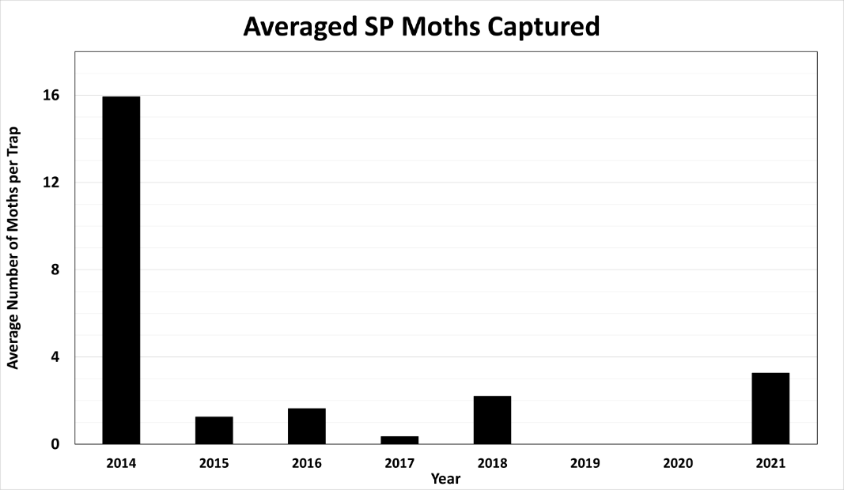
Figure 10. Average number of saddled prominent (SP) moths captured per trap from 2014-2021. Note that no trapping was conducted in 2019 or 2020. Three multi-pher pheromone traps per site, with aPhinity SP lures, were used in 2021.

Maple Anthracnose
Maple Anthracnose (causal agents Aureobasidium apocryptum, Discula campestris, and Colletotrichum gleosporoides) reports increased throughout the growing season due to persistent late-season rainfall. Reports came from Addison, Caledonia, Franklin, Rutland, Washington, and Windsor counties. Although present throughout most of the state, aerial detection surveys did not detect damage in all counties. This is most likely due to the timing and prevalence of MLC on the landscape, which may have masked symptoms otherwise visible from the air.

Oak Wilt
Oak Wilt, caused by the fungal pathogen Bretziella fagacearum, is not known to occur in Vermont. Due to recent detections in New York State, Vermont and nearby states are participating in a regional effort to monitor for this pathogen. In Vermont, the primary detection method is outreach, with an estimated 3,300 contacts through newsletters and social media and 420 contacts through workshops in 2021. As a result of this effort, four oak wilt suspects were reported in 2021, however, symptoms were not consistent with oak wilt and no samples were sent for lab testing.

Red Pine Health
Red pine (Pinus resinosa) has been in a state of undetermined decline across Vermont over the last decade. Starting in 2010, pests and pathogens observed in declining red pine stands included pine engravers (Ips pini), pine gall weevils (Podapion gallicola), parasitic woodwasps (family Orussidae), armillaria root rot (Armillaria spp.), diplodia shoot blight (Diplodia sapinea) and Sirococcus shoot blight (Sirrococcus conigenus). These observations remained consistent until 2013, with the addition of European pine sawflies (Neodiprion sertifer) and in 2015, with the addition of red pine scale (Matsucoccus resinosae). In 2017, annosus root rot (Heterobasidion annosum) was also observed. Although all biotic stressors are capable of reducing tree health and vigor, no individual pest or pathogen observed was determined to be the causal agent of this decline.
To try and determine the causal agent of this decline, 12 monitoring sites were established and sampled in 2020 to try and observe red pine decline symptoms across the state. Foliar pathogens included diplodia tip blight and sydowia blight (Sydowia polyspora). Insect pests observed included pine gall weevil, pine needle scale, and sawflies. Although no single observed stressor was identified to be the causal agent of this decline at this time, current hypotheses are that this declining pattern in red pine health is a combination of abiotic and biotic factors which include severe recent droughts, as well as the before mentioned insect stressors and fungal pathogens.
By establishing monitoring sites across the state, FPR will be able to observe and document red pine decline spread and severity. These sites will allow us to better understand red pine health and future management across the state.

White Pine Needle Damage
White pine needle damage (WPND) is a fungal complex of four different foliar pathogens, Bifusella linearis, Lecanosticta acicola, Lophophacidium dooksii, and Septorioides strobi, that have been associated with both needle cast and needle blight on eastern white pine trees throughout Vermont. Although this is an increasingly damaging complex, individually these pathogens are not documented as causal agents of large-scale defoliation. Chlorosis (yellowing) and necrosis (browning) of 1-year-old needles from infected trees have been observed, with heavy infections causing defoliation and dieback. WPND accounted for 2,683 acres of observable damage on white pine trees throughout the state in 2021 (Figure 11 and 12).

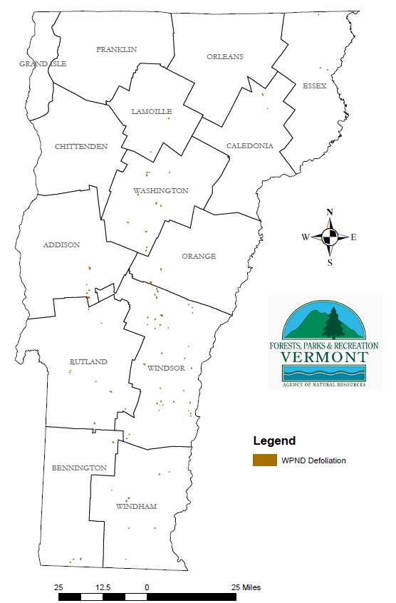

Figure 11. Defoliation caused by white pine needle diseases (WPND) affected 2,683 acres in the state in 2021.

Figure 12. Mean chlorosis (yellowing) and defoliation of white pine trees from four plots (n = 50) in Vermont. Mean severity score indicates what portion of the crown is impacted (1 = 1/3, 2 = 2/3, 3 = entire crown).
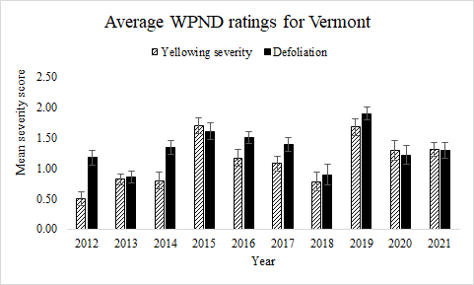
The expression of WPND is linked to the amount of humidity and moisture from the previous spring (e.g., 2021 damage is influenced by 2020 weather). Spore production typically peaks in June during shoot elongation. We expect WPND to be present again in 2022, but to be less severe than in recent years due to the dry spring in 2021.

Invasive Plant Programs
Through the thick of the pandemic, the Forest Health Invasive Plant Program (IPP) continued invasive plant management efforts with creative solutions to meet 2021 safety guidelines. Control, outreach, and education programs progressed through multiple grant-funded streams -- since 2014, almost 4,000 volunteers have assisted the program with direct management of invasive plants in Vermont. This year, the IPP offered virtual workshops to local municipal road crews, state recycling coordinators, Agency of Natural Resources staff, and Cooperative Invasive Species Management Areas (CISMAs); participated in local initiatives like Wild Foods; and created a video that was published on the Agency of Natural Resources (ANR) YouTube site as part of Municipal Day 2021. IPP staff fielded hundreds of inquiries about invasive plants – an upward trending pattern that we hopefully attribute to more people spending time on the land, in the forests, and on the trails.
The Forest Hero! Network was established in late 2018, with 5 trainings conducted between 2018 and 2021. The Network trains individuals to act as local leaders to motivate their communities to engage in invasive plant management; it is a collaboration between Vermont Coverts: Woodlands for Wildlife, Vermont Department of Forests, Parks & Recreation, and VTinvasives.org. The IPP moved the training online this spring, with 11 people completing the training in 2021. In total, 41 people have completed the training.

