Vermont Land and Water Conservation Fund Grant Program
2017 Application Supplement

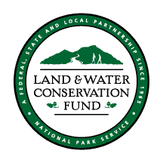

Pre-Application Due Date:
October 1st, 2016

Full Application Due Date:
No later than 12:00 Noon

December 16, 2016

Foreword

This supplement is designed to assist applicants in applying for federal funds available under the National Park Service’s Land and Water Conservation Fund (LWCF) program. It is separated into three parts, Part A: Completing the Application, Part B: Project Approval and Administration, and Part C: Appendix.

Part A summarizes the Land and Water Conservation Fund program, presents the rules and regulations governing disbursement of federal funds, discusses project selection criteria and describes the materials required for a complete application. Part B of the Supplement provides an overview of the federal approval process and is meant to assist sponsors with administering their projects after federal approval. Part C provides supplemental information including a map of Regional Environmental Offices, samples of maps to be created for the application and a summary of the 2014-2018 SCORP Key Findings and Desired Conditions.

It is hoped that the material presented will answer many questions about the program. If further information or clarification is needed at any time during the application or administration stages of the grant, please contact:

Jessica Savage, Recreation Program Manager
Land and Water Conservation Fund
Vermont Department of Forests, Parks and Recreation
1 National Life Drive Davis 2
Montpelier, VT 05604
802-249-1230
jessica.savage@vermont.gov

Information can also be found on our website by clicking: http://fpr.vermont.gov/recreation/grants/lwcf

Information about the LWCF State Assistance Program including contact information for National Park Service Regional Offices can be found on the Web at www.nps.gov/lwcf.

The Land and Water Conservation Fund is subject to the provisions of Title VI of the
1964 Civil Rights Act, Section 504 Rehabilitation Act of 1973 and the Age Discrimination Act of 1975. Under these acts, the U.S. Department of Interior strictly prohibits discrimination because of race, color, handicap, age, or national origin in its federally assisted programs.

The Vermont Agency of Natural Resources is an equal opportunity agency and offers all persons the benefit of participating in its programs and in competing in all areas of employment regardless of race, color, religion, sex, national origin, age, disability, sexual preference, or other non-merit factors.
Important Points

The Land and Water Conservation Fund (LWCF) Program provides matching grants to States and local governments for the acquisition and development of public outdoor recreation areas and facilities (as well as funding for shared federal land acquisition and conservation strategies). The program is intended to create and maintain a nationwide legacy of high quality recreation areas and facilities and to stimulate non-federal investments in the protection and maintenance of recreation resources across the United States.

LWCF is a reimbursement program; therefore, the grant recipient must pay 100% of the cost of any item before submitting a request for reimbursement for eligible costs. This includes acquisition costs. Reimbursement in federal funds can be made for up to 50% of the total approved project costs as approved in the grant agreement.

Eligible Applicants/Project Sponsors:
- Cities
- Towns
- Villages
- School districts
- Fire districts
- Inter-municipal districts

• Project sponsors must have control and tenure of the property and agree that the area within the project boundary be retained in perpetuity for public outdoor recreation use. LWCF regulations only permit funding for projects on leased land on a very limited basis.

• Park areas acquired and/or developed with LWCF assistance are federally protected and may not be converted to non-outdoor recreational use without the approval of the National Park Service. This requirement is included in section 6(f) of the Land and Water Conservation Fund Act and is commonly referred to as the “6(f) requirement”.

• When applying for LWCF assistance a 6(f) project boundary map is to be created for the public outdoor recreation area being acquired and/or developed. If a structure exists on the property that serves to support other than outdoor recreation (i.e. school, town garage) please indicate its location on the map but omit it from the park boundary area by at least a 50 foot buffer. Public access must also be guaranteed for LWCF assisted sites to ensure they are self-sufficient.

• Grantees and subgrantees shall use their own procurement procedures that reflect applicable state and local laws, provided the procurements conform to the requirements of 2 CFR 200.

• The sponsor is responsible for any costs incurred in excess of those included in the confirmed cost estimate.

• A 5% retainer of the LWCF grant amount will be withheld until project is completed and a final inspection has been performed by our office.

Part A:
Introduction to the Land and Water Conservation Fund
(LWCF) and the Grant Application Process

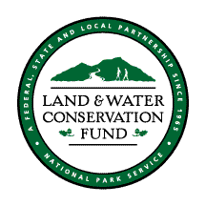

LWCF Grant Program Timeline 2016-2017

August 2016
FPR will make the announcement that the grant application process has begun.

October 1, 2016
Pre-applications are due to FPR. Submit pre- applications electronically (including maps, photos, etc.). Site visits will be scheduled soon after receipt of pre-applications.

October, 2016- March 15, 2017

Pre-application site visits are conducted by FPR staff to determine eligibility of proposed work and help resolve any questions prior to the ranking committee meeting.

December 16, 2016
Full Applications are due to FPR no later than 12 noon.

December 16, 2016- January 16, 2017

Applications are reviewed for completeness and eligibility by FPR Staff and forwarded to Project Application Ranking Committee (PARC) members.

January 16, 2016

PARC will meet for preliminary funding recommendations. NOTE: project sponsors will be invited to present their projects and answer questions by the committee. The committee scores and prioritizes applications using established criteria.

March 1, 2017
Funding recommendation announcements made by FPR. Applications now begin the federal approval process.

NOTE: No grant related work may begin prior to National Park Service approval.

Summer 2017
When a project is recommended for funding, it is just the beginning of the federal approval process, which may take a few months. The sponsor can take this time to apply for all local, state, and federal permits and clearances. FPR will work with sponsors to obtain any additional documents that are required as part of the application to National Park Service. A series of federal forms are completed by FPR to be submitted with each project’s application. Federal approval can take anywhere from 4- 8 weeks once the completed application materials are sent to NPS. A Project Agreement between the sponsor and FPR is made when federal approval is secured.

History of the Program
More than 40 years ago, the Visionary Outdoor Recreation Resources Commission recommended creation of the Land and Water Conservation Fund in response to the fundamental need for local recreational opportunities. In September 1965, the U.S. Congress approved and the president signed Public law 88-578, the Land and Water Conservation Fund Act of 1965. Section 4601.4. The Statement of Purpose explains the program is meant “… to assist in preserving, developing and assuring accessibility to all citizens of the United States of America of present and future generations … such quality and quantity of outdoor recreation resources as may be available and are necessary and desirable for individual active participation…” This law, as amended, uses funds derived from entrance or admission fees to federal recreation areas, Outer Continental Shelf (OCS) revenues from leasing oil and gas sites in coastal waters, federal surplus real property sales and a small portion of federal motorboat fuel taxes, to provide matching grants to the states and units of local government for the acquisition and development of public outdoor recreation areas and facilities. The federal administering agency is the Department of the Interior, National Park Service (NPS).

LWCF has provided over 100 Vermont communities and state agencies with more than $26 million towards the acquisition, conservation and development of outdoor recreation areas and facilities. The Land and Water Conservation Fund helps states and communities preserve important recreation opportunities and protect environmentally sensitive areas now and for the future by providing matching grants to states for acquiring state and community parks.

Because recreation is a significant contributor to the economy of many communities, new or renovated parks and trails are a proven catalyst to community revitalization and can attract tourist dollars. Proximity to parks, open spaces and recreation facilities also increases real estate values. Relocations decisions by many businesses and families are partly based on the availability of park and recreation facilities. By providing matching funding for both open space acquisition and recreation development at the local and state level, the Land and Water Conservation Fund is an essential factor in the local economic equation.

Overview of Vermont's LWCF Program

Distribution of Funds
Vermont receives an annual apportionment of stateside funds. The remainder is divided in half: 50% is for municipal outdoor recreation grants and 50% is for outdoor recreation projects on state lands, usually state parks.

Eligible Applicants
LWCF grants are available only to municipalities (i.e. any governmental entity, cities, towns, park districts, school districts, fire districts, etc.). Non-profit organizations and private entities are not eligible applicants.

Eligible Projects and Project Costs
There are two general categories of projects that can receive LWCF funds: Acquisition and development. Funds are available for the acquisition of lands and waters or for the development and enhancement of public outdoor recreation facilities that are consistent with the outdoor recreation goals and objectives highlighted in the Statewide Comprehensive Outdoor Recreation Plan (SCORP) and recreation elements of local plans.

Acquisition

For full details of acquiring land with LWCF assistance, be sure to read the LWCF Manual (http://www.nps.gov/ncrc/programs/lwcf/manual/lwcf.pdf)

NOTE: You MUST have a complete appraisal, and a review appraisal of the property which confirms that the appraisal meets the “Uniform Appraisal Standards for Federal Land Acquisitions.” A copy of this document may be found at http://www.justice.gov/enrd/land-ack/Uniform-Appraisal-Standards.pdf.

The Land and Water Conservation Fund Program in Vermont has assisted with the acquisition of thousands of acres dedicated to outdoor recreation and the conservation of unique or endangered plant and animal habitat. The most common method of acquiring property is by fee simple title. This is the preferred method of acquisition since it gives the holder an absolute right to the property within limitations imposed by state or federal law. In some instances, the sponsor may wish to purchase less than fee simple title, such as easements, rights-of-way and title subject to deed restrictions. This would be permissible when fee simple is excessively expensive and a lesser control of the area will not detract from recreational use of the land.

Areas acquired may serve a variety of outdoor recreation activities including: walking, sightseeing, swimming and other water sports, picnicking, nature study, boating, hunting and shooting, camping, horseback riding, bicycling, snowmobiling, skiing, athletic fields, public playgrounds, and other outdoor recreation activities. Acquisition projects may also include structures which are to be used for outdoor recreation or support facilities for outdoor recreation.

The Department of the Interior National Park Service and the State of Vermont require procedures for the acquisition of property that are fair, consistent, and directed toward giving the property owner the full measure of compensation authorized by law, promptly, with a minimum of inconvenience, and without prolonged negotiation or costly litigation. All acquisitions must conform to the Uniform Relocation Assistance and Real Property Acquisition Policies Act of 1970, P. L. 91-646.

Important: To receive Land and Water Conservation Funds for your acquisition, do not acquire any land until federal approval has been obtained.

Eligible Acquisitions
An acquisition project should include the purchase of land for outdoor recreation purposes. A project may involve the acquisition of land to create a new park or expand an existing park. It may also consist of the acquisition of land for more than one park if the parks are of the same type. An example of a multi-site acquisition project is the purchase of land for two neighborhood parks or parcels for access points along a river to create a greenbelt park corridor.

Some examples of eligible acquisitions of land and water for public outdoor recreation include, but are not limited to:

- Community parks - sites in rural areas serving local, regional, and county recreational uses, such as camping, hiking, hunting, fishing, picnicking.
- Existing Recreational Facilities - privately owned facilities, such as swimming pools, golf courses and youth camps, which will no longer be operated by the private sector. The acquisition of an area or facility which is operated for public recreation is only eligible for LWCF assistance if it can be documented that the facility will be lost to recreation use if it is not acquired by the municipality/governmental entity.
- Linear parks - land which forms a greenbelt corridor for recreational use, such as a bike path or a multi-purpose trail, or a series of access points to a river for boating and fishing.
- Natural and Scenic Areas - natural areas, preserves and outstanding scenic areas, including areas adjacent to scenic highways, where the objective is to preserve the scenic or natural values, including areas of physical or biological importance and wildlife areas. These areas must be open to the general public for outdoor recreation use to the extent that the natural attributes of the areas will not be seriously impaired or lost.
- Structures - the acquisition of structures on property if the use will be for outdoor recreation, support of outdoor recreation activities or the structures have no value and are demolished to enable recreational development to take place. Project proposals must list all improvements and their proposed use or disposition.
- Water-Oriented Recreation Sites - areas with frontage on rivers, streams, lakes, estuaries, and reservoirs; water bodies themselves; land for creating water impoundments; and areas that provide special recreation opportunities, such as floodplains and wetlands.

Acquisitions Ineligible for Assistance:

- Historic sites and structures.
- Museums and sites to be used for museums or primarily for archaeological excavations.
- Land to help meet a public school's minimum site size requirement, as established by State or local regulations.
- Areas and facilities designed to be used primarily for semi-professional and professional arts and athletics.
- Areas and facilities to be used solely for game refuges or fish production purposes.
- Areas to be used mainly for the construction of indoor facilities. Also prohibited are areas where existing indoor recreation facilities, if left in place, will not leave sufficient area at the site for development of outdoor recreation facilities to justify the cost of the acquisition.
- Sites containing luxury lodges, motels, cabins and similar elaborate facilities which are to be operated by the project sponsor or concessionaire to serve recreationists with food and sleeping quarters.
- Agricultural land primarily for preservation in agricultural purposes

Pre-Agreement Acquisition Costs:

There are NO pre-agreement costs that are eligible for LWCF reimbursement involving land acquisition.

Exceptions may be made only when absolutely necessary, and only if the applicant stands to lose an opportunity to acquire a significant piece of property if action to secure property is not taken immediately. In these circumstances it is possible the National Park Service (NPS) may grant a Waiver of Retroactivity allowing the sponsor to proceed with the acquisition prior to project approval. If the project is approved at a later date, the costs will be eligible for assistance. It is not a commitment on the part of the State or NPS to award a grant for the project but merely a waiver of the requirement that only costs incurred after project approval are eligible. A waiver does not constitute a commitment on behalf of the sponsor to purchase the property and it does not imply a qualitative approval of the project. To request a waiver of retroactivity, submit the following to FPR:
- A letter of justification requesting the waiver (include a detailed description and reasons for the request).
- Parcel, site, and location maps.
- An environmental assessment of the proposed park, if applicable.
- Any other documentation that might be appropriate such as a letter from the property owner declaring his intent to sell the land quickly.

The applicant must not move forward with the acquisition until the "Waiver of
Retroactivity" has been approved by National Park Service.

Eligible Acquisition Costs:

- Purchase costs of real property.
- Purchase costs of easements and other rights and interest in real property.
- The value of real property donated to the project sponsor by private entities may be eligible for the sponsors matching share, as determined by appraisal.
- Incidental and relocation assistance costs ONLY as allowed by the Uniform Relocation Assistance and Real Property Acquisition Policies Act.
- Acquisition costs of land from another public agency at the minimum cost allowed by law.
- Costs of real property acquired through exchanges, subject to appraisal requirements, for one tract of land having greater value than another.

Ineligible Acquisition Costs:
Incidental costs relating to the acquisition of real property and of interests in real property such as appraisal fees, legal fees or legal boundary map expenses, unless allowable under the Uniform Relocation Assistance and Real Property Acquisition
Policies Act, PL 91-646, are not allowable.

Development

Development projects can be the construction or rehabilitation of outdoor recreation facilities or areas. A major rehabilitation project may consist of the repair, restoration, or reconstruction of eligible facilities, which is necessitated by obsolescence, building code changes, or normal wear and tear not attributed to a lack of maintenance.

Plans for the development of land and/or facilities should be based on the needs of the public, the expected use, and the type and character of the area. Facilities should be attractive for public use and generally be consistent with the surrounding environment. Plans and specifications for the improvements and/or facilities should be in accord with established engineering and architectural practices. Emphasis should be given to the health and safety of users, accessibility to the general public, and the protection of the recreation and natural values of the area. Facilities can only be developed on properties that the project sponsor has title to or complete control and tenure.

Eligible Facilities (examples):

- Sport playfields
- Hiking, biking and walking trails
- Camping
- Picnic facilities
- Boating facilities
- Swimming areas
- Playground areas
- Restroom buildings
- Roads, parking, landscaping, and walkway

Ineligible Facilities (examples):

- Indoor facilities (except swimming pools and ice skating rinks)
- Community centers
- Historic buildings
- Park manager’s residences
- Meeting rooms
- Auditoriums
- Maintenance equipment
- Commercial-type amusement centers

Eligible Costs for Development:

- Construction costs, which may include necessary construction activities from site preparation to completion of the project within limits of the scope of work.
- Certain types of permanent recreation equipment are eligible, provided it is required by state law or regulation to make a facility initially operable. Such equipment might include sprinkler systems, pumps, lifeguard stands, tennis nets, baseball backstops and similar items.
- Informational and directional signs at entrances, exits, or other necessary locations throughout the project area, interpretive facilities for items of particular interest, and certain other facilities intended to explain the project or draw the public to it.
- Cost of purchasing, leasing, or renting items of equipment clearly necessary for successful completion of the project can be eligible for fund assistance. The purchase of equipment for maintenance or operational purposes (i.e. mowers) is not eligible.

Pre-agreement Costs for Development:

The costs of site investigation and selection, site planning, feasibility studies, preliminary design, environmental assessment, preparation of cost estimates, construction drawings and specifications may be eligible for assistance although incurred prior to project approval.

The use of professional, outside consultants in the formulation of project proposals is encouraged. Thus, the development of work programs, cost estimates and budgets, work flow charts, and such other items as are necessary to develop a sound planning program by outside consultants, university personnel, or by appropriate state personnel may be allowable costs, although incurred prior to project approval.

All pre-agreement planning costs incurred within three years prior to project submission to National Park Service are allowable. Eligible planning costs incurred beyond three years may be allowable provided the earliest date from which they are incurred is identified in the project agreement. The sponsor must provide sufficient information to justify the amounts of such pre-agreement costs, periods during which they were incurred and their purpose to justify the applicability to the particular project. If you question the eligibility of any costs related to your project, contact our office.

Applicants should be sure to follow the procurement standards for hiring a consultant. A number of proposals must be solicited from qualified consultants and the applicant must be able to document why they made their particular choice.

Ineligible Costs for Development:

NOTE: These expenditures cannot be included in the project cost estimate as a basis for determining financial assistance because they are not eligible for reimbursement.
- Ceremonial or entertainment expenses
- Expenses for publicity
- Bonus payment of any kind
- Charges for contingency reserves or other similar reserves
- Charges for deficits or overdrafts
- Taxes for which the organization involved would not have been liable to pay
- Interest expenses
- Charges incurred contrary to the policies and practices of the organization involved
- Damage judgments arising out of acquisition, construction, or equipping of a facility, whether determined by a judicial decision, arbitration or otherwise
- Operation and maintenance costs of outdoor recreation areas and facilities
- Cost of discounts not taken
- Equipment to be used for the ongoing maintenance of outdoor recreation areas and facilities including, but not limited to, automotive equipment, tractors, mowers, other machinery and tools
- Employee facilities including residences, appliances, office equipment, furniture, and utensils
- Donations or contributions made by the sponsor, such as to a charitable organization
- Salaries and expenses of the office of the Governor or of the chief executive of a political subdivision, or of the State legislature or similar local governmental bodies
- Fines and Penalties
- The sponsor is responsible for any costs in excess of those included in the confirmed cost estimate
- Any losses and related costs arising from uncollectible accounts and other claims
- Legal and professional fees paid in connection with raising funds

School Related Projects:

Playgrounds and outdoor recreation facilities on public school grounds for joint school/general public use are eligible, provided that the facilities are not part of the normal and usual program and responsibility of educational institutions and that they otherwise meet requirements for a grant under the LWCF program. Facilities needed to meet the physical education and athletic program requirements of a school may not receive fund assistance. The grant application must include a schedule of the time the facility will be available to the public. The schedule of use substantiates the primary intent of the project as being public community outdoor recreation. Additionally, adequate signs must be installed, prior to final payment on the project, at the site indicating when the outdoor recreation facilities are available to the general public.

Use of federal money for playground equipment requires meeting national safety standards. The US Consumer Product Safety Commission developed the "Handbook for Public Playground Safety" as a blueprint to help local communities and other groups build safe playgrounds. This handbook includes technical safety guidelines for designing, constructing, operating and maintaining public playgrounds. Please contact the LWCF office for a copy or go to the US Consumer Product Safety Commission’s website at http://www.cpsc.gov/PageFiles/122149/325.pdf.

The development of facilities primarily for the interscholastic sports, such as stadiums, and athletic fields with grandstands or more bleacher seating than would normally be required for non-interscholastic athletic use, are not eligible for assistance.

IMPORTANT: The investment of LWCF funds in a parcel requires that the 6(f) area not include any structures for other than the support of outdoor recreation. Once LWCF funds are invested in a parcel, the area within the project boundary may not be converted to any use other than outdoor recreation without the approval of the Secretary of the Interior. This means that school facilities may not be expanded into the designated recreation area. For this reason, it is recommended that when creating a 6(f) boundary area that a buffer zone of 50 feet be maintained around any buildings that are not involved in outdoor recreation (Refer to the next section for more information on the Section 6(f)(3) of the LWCF Act).

Section 6(f)(3) of the LWCF Act

Section 6(f)(3): No property acquired or developed with assistance under this section shall, without the approval of the Secretary, be converted to other than public outdoor recreation uses. The Secretary shall approve such conversions only if he finds it to be in accord with the then existing comprehensive statewide outdoor recreation plan and only upon such conditions as he deems necessary to assure the substitution of other recreation properties of at least fair market value and of reasonably equivalent usefulness and location.

This requirement applies to all parks and other sites that have received funds from LWCF whether for acquisition, development, or rehabilitation. As a result of this act applicants are asked to submit a 6(f)(3) boundary map which delineates the area being developed or acquired with federal LWCF funds. This area will be afforded the protection of Section 6(f)(3) of the LWCF Act ensuring that the area is reserved for outdoor recreation in perpetuity.

The 6(f)(3) map also ensures that the area delineated by the boundary line is a self- sustaining recreation unit. Normally this will be the total area of the unit receiving LWCF assistance. In no case will the area be less than the area to be developed or acquired under this LWCF application. At a minimum, the area must include a logical management unit within the park to include parking and public access.

NOTE: Instructions for developing a 6(f) map to be included in your application can be found later in this supplement.

Completing the Application

The following information is provided to assist you in completing your LWCF Application. Although the actual quality and completeness of the application can earn the project up to 5 points, the success of your project, otherwise the amount of points awarded, will depend to a large extent on the information presented in your application, therefore making the quality and completeness much more valuable. For this reason, particular attention should be paid to all documentation required.

This checklist has been provided as a guide for compiling your application. Instructions follow expanding on each requirement.

Pre-Application Form (as a pdf, emailed to jessica.savage@vermont.gov)

- Complete form including cost estimate and project description
- Optional: submit maps, site plans and photos

Full Grant Application (as a pdf, emailed to jessica.savage@vermont.gov)

- Project Summary
- Application Narrative
- Cost Estimate
- Sponsor’s Match Summary
- Sponsor Resolution

Attachments (as separate pdf files emailed to jessica.savage@vermont.gov)

- Geographic Location Map
- Site Plan Map
- Site Plan
- 6(f)(3) Legal Boundary Map (signed and dated by the sponsor)
- Acquisition Parcel Map
- Deed References (if you do not have a deed that describes the property please submit a legal description to support the 6(f) map.)
- Copy of Permits Obtained
- Environmental Project Review Sheet
- Photographs of Site
- One copy of an appraisal for acquisition projects

Application Forms

Part I: Pre-Application Form
This form is used to provide information to FPR staff in order to schedule a required site visit as soon as possible.

Part II: Full Application Project Summary
This section of the application provides information about the proposed project for administrative purposes and is not used to judge your application.

Part IIIA and B: Application Narrative
The questions in this section provide the sponsor with the opportunity to describe how integral the proposed project is to the community, what planning has gone into the project and any unique characteristics that will make the project stand out. Please answer all questions in narrative form and begin by restating the question.

Part IV: Cost Estimate All LWCF grant applications must include a breakdown of estimated project costs. Accurate costs should be developed based on the anticipated costs of completing the project within the appropriate time schedule identified by the sponsor. This is not limited to expenses paid out but includes in-kind labor and/or donated materials or services.

Acquisition
Projects that include the acquisition of land through negotiated purchase, donation, or bargain sale should clearly identify the value of each parcel of land to be purchased and relocation costs, if any. Incidental costs to the acquiring agency associated with land acquisition such as appraisal fees, title transfers, recording fees or the like are not eligible for reimbursement under the LWCF program and should not be included as part of the project costs. All parcels to be acquired should be listed in priority order with high priority parcels appearing first.

Development
The cost estimate has been broken into six (6) categories that cover different aspects of developing a recreation area or facility. Complete each category that applies to the project's scope of work, include a brief explanation and the estimated cost in the spaces provided. If any line items are not applicable, please write “N/A” and enter $0 in the dollar amount column. The categories are explained below.

A. Grant administration – You must document costs involved in the general administration of the project, post-approval of your grant agreement. This can involve record keeping, preparing reimbursement requests, drafting requests for proposals and collecting price quotes, scheduling work crews, and purchasing materials. Specify wages for staff time and estimated hours to be devoted to administration.

Example: Administration time (1 staff x 100hrs x $20/hour): $2,000.00

B. Construction design and engineering - This section is for documentation of costs for design and engineering of recreation areas and facilities such as pavilions and bathhouses. Please refer back to page 9 for information about eligible pre-agreement design and engineering costs. Be sure to specify wages and estimated hours.

Example: Professional engineer (24hrs x $50/hour): $1,200.00

C. On-site construction labor - This section is set up so you can delineate skilled and un-skilled labor involved in the construction of the project. Skilled labor is considered work performed by a person that has done the work in a professional capacity. The rate used should either be the rate they are earning or the current going rate for that skill. Unskilled labor is any work performed by a person that does not or has not done the work in a day-to-day professional capacity. The rate to be used is the state minimum wage rate in the year which the labor is being performed $9.60 per hour until January of 2016, when it should increase to $9.17 per hour for 2015, and should increase on January 1, 2017.) See http://labor.vermont.gov/ for more information.
Example:
Town equipment operator (16hrs x$14/hour): $224.00
Un-skilled volunteers (20 x 8hrs x $9.60/hour): $1,536.00

D. Construction equipment - The purchase of equipment may be necessary for a project particularly if it is more cost effective than renting the equipment. List anticipated purchases and their current price. When documenting equipment rental please list each piece of equipment to be rented, the rental rate and the estimated number of hours it will be rented for. If someone is donating the use of a piece of equipment, use its current rental rate. Remember that the operators of this equipment are considered labor and should be documented in Part C. The use of town labor and equipment is similarly documented. Town equipment operators should be included in Part C and the cost of equipment use is documented here.

E. Materials - Document all materials needed for the project including purchases and donations.
Example:
Gravel (truck load) $ 200.00
5 picnic tables $2,250.00

F. Others expenses not included above - If you have costs you do not believe fit into any of the above categories they can be listed here. Be sure to provide rates and hours if appropriate.

G. Summary of total project costs and funding sources - Add all subtotals and enter the dollar amount on the Total All Costs line. When the Sponsor's Match Summary section has been completed, subtract that total from the total costs. This will give you the total grant request and sponsor's match; grant rates can then be calculated.

including sources of funds.

Part V: Sponsor’s Match Summary

List and describe all sources and dollar amounts of non-LWCF funding that will be used for this project. Sponsor's match must equal at least 50% of the total project cost and can be a combination of donations of land, labor, equipment use or materials.

Donated Land
In order to determine the value of donated land as a source of match, the Sponsor (at their expense) needs to obtain an appraisal of the property. If the appraisal is over $100,000, NPS will need to review and approve the donation, otherwise the appraisal can be approved by FPR. Appraisal needs to be performed according to Uniform Appraisal Standards for Federal Land Acquisitions.

In-Kind Labor Contributions
Professional and technical personnel, consultants, and other skilled and unskilled laborers may furnish volunteer services. The time of a person donating services will be valued at the rate paid as a general laborer unless the person is professionally skilled in the work being performed for the project (i.e. surveyor surveying a property, heavy equipment operator operating an excavator). When this is the case, the wage rate that this individual is normally paid for performing this service may be charged to the project. The value of un-skilled laborers should be calculated using the state's minimum wage rate in the year it is being performed. (See http://labor.vermont.gov/ for more information). An un-skilled laborer is considered any person performing a task for the project that does not or has never performed the task in a professional capacity. Time and Attendance Report Forms are provided with the reimbursement request packet to assist the sponsor with keeping records for labor.

Donated Materials
Prices determined for donated materials to be included in the sponsor’s match should be reasonable and not exceed current market prices at the time they are donated to the project.

Equipment Donation
The hourly rate for donated equipment used for a project shall not exceed its fair market value. Records of in-kind contributions of equipment shall include schedules showing the rates, hours and dates of use. Please provide a signature to attest to the use of this equipment for the project. Remember to separate the cost of the equipment donation from the cost of the operator because the operator is considered donated labor.

Example:

Source of match Value
Unskilled Volunteers (20 x 8hrs x $8.73) - In-kind $1,396.80
Sand - Donation $ 200.00
Cash - Donation $2,237.00
Total Sponsor's Match $3,833.80

The total of the Sponsor's Match Summary should be entered in Part G of the Cost Estimate to calculate the grant request and corresponding percentage rates. Please round figures.

Example: | Total all Costs | $7,668.00
 | Subtract total sponsor match | $3,834.00 | 50%
 | Total grant request | $3,834.00 | 50%

Part VI: Historic, Archaeological and Environmental Review

Applications recommended for funding by the ranking committee are given to Fish and Wildlife for review in order to anticipate any negative impacts to endangered species or habitats. The Division for Historic Preservation also plays a role in the approval process for projects. Their role is described in more detail below. The information you provide in this section is used in their reviews of your project. It is therefore important that you give as much detail as you can in order to make this process as efficient as possible.

Because the Land and Water Conservation Fund is a federally funded program, compliance with the National Historic Preservation ACT of 1966 (as amended) is required (see http://www.achp.gov/docs/nhpa%202008-final.pdf for the complete Act). The National Park Service must ensure that projects receiving LWCF assistance do not have an adverse effect on significant historic and archaeological resources.

All projects recommended for funding are reviewed by the Division for Historic Preservation.

If a site visit is determined to be necessary, the project sponsor will be instructed to make arrangements with an archaeological consultant. If the site visit prompts a need for any further investigation (i.e. a phase I investigation), arranging and paying for this investigation is the responsibility of the project sponsor. This cost may be considered an eligible pre-agreement cost when included in the cost estimate. Any recommendations by the archaeologist will become part of the Project Agreement with FPR.

Although an archaeological review is not necessary at the time the application is submitted, some consideration may be given to projects which have received ‘sign-off’ or otherwise have a full understanding of the level of archaeological or architectural historian review and coordination which will be necessary. Also, some preliminary investigation will assist sponsors in preparing an accurate project cost estimate.

If the project involves demolition, rehabilitation, or use of a building or structure 50 years old or older, an architectural historian will need to make a preliminary assessment of the potential issues and make recommendations. In many cases, the preliminary assessment may be all that is required. In other cases, additional steps may be necessary to ensure compliance with federal laws. Any recommendations may be made part of the Project Agreement with FPR.

Environmental Assessments
The environmental impact of all projects is considered by National Park Service before approving projects. Certain projects obviously will not significantly affect the environment and may qualify for a "Categorical Exclusion". Other more involved projects may require an Environmental Impact Statement or an Environmental Assessment. FPR will notify sponsors that are recommended for funding if an environmental assessment is necessary and will supply the necessary information for compiling a statement. This documentation will be included in the final application materials forwarded to NPS.

Permits
It is the responsibility of the project sponsor to make sure that all permits are in place before the project commences. To determine whether permits are needed for your project, please contact the Permit Specialist for your region before January 1st in order to meet application deadline requirements. See http://dec.vermont.gov/sites/dec/files/ead/documents/permitbro_10-27-15.pdf to locate your permit specialist.

You must submit a project review sheet along with your application. This will be completed by a permit specialist.

In the event that a review has been initiated at the time of application for any of the environmental or historical clearances, we ask that you submit them to assist in our approval process.

Part VII Sponsor Resolution Form
The sponsor resolution form is to be signed at the time of completing the LWCF application. It basically certifies that all materials are consistent with the current Vermont Recreation Plan and the sponsor agrees to comply with all applicable federal and state regulations. It will also certify that the sponsor will provide a certain amount of money as a match and can finance 100% of the project up front. Have an authorized official of the sponsor (i.e. Town Manager, Select Board Chair, Superintendent, School Board Chair) sign and submit the Sponsor Resolution Form with the application if the sponsor can agree to the terms outlined in the resolution.

Part VIII Maps, Photographs, and Other Attachments
Descriptions of the maps to be submitted with project applications can be found on the last pages of the grant application. Photographs of the site are helpful but not necessary, as they will be taken at the pre-award site inspection after your application is submitted. Samples of the different maps required for a complete application can be found in the appendix.

Town parcel maps or tax maps are often used for 6(f)(3) boundary maps because the metes and bounds are indicated on the map. If measurements are not available for the proposed site a map can be created by the sponsor. Remember that although a formal survey is not required, the 6(f)(3) boundary map must be drawn from actual fixed points on the property (i.e. iron pins, concrete monuments, tide lines, and/or other permanent landmarks). The 6(f)(3) map must be signed by the sponsor. In addition to the map a legal description of the property needs to be submitted. This can be in the form of deed references or a legal description. A legal description is a written description of the property to be set aside, with metes and bounds and a signature by an authorized official of the sponsor. Sample legal descriptions can be found in the appendix.

Any structures (i.e. schools and town garages) that will not contribute to outdoor recreation must be excluded from the 6(f)(3) boundary area. However, it is helpful if the structures are included in the map for reference. If the sponsor is using a parcel map with a deed description of the metes and bounds, a buffer zone has to be drawn onto the map (using permanent landmarks) of at least 50 feet around the structure. This is to prevent any conversion of use issues due to any future expansion of the existing structure. To supplement the deed, a legal description needs to be written with metes and bounds describing the land to be excluded from the 6(f)(3) area and signed by an authorized official of the sponsor. An example of a buffer zone created around a structure, such as a school, can be found in the appendix.

NOTE: 6(f)(3) boundary areas must ensure public access by including parking lots, walkways to parking areas, or access roads

Other Helpful Information:
Contracting Guide
The Vermont League of Cities and Towns (VLCT) created a manual for municipalities as guidance for contracting municipal projects. This publication can provide detailed information to sponsors on how to plan projects and carry them out successfully. The manual can be obtained by calling VLCT at 800/649-7915.

Project Selection
All applications submitted by the deadline are checked by FPR staff for eligibility and completeness. When weather permits, staff begins scheduling pre-award on-site inspections. These inspections will summarize the utility of the site for its intended use, confirm the 6(f)(3) boundary area and respond to questions. Photos should be provided by the sponsor to record the site conditions before the project begins.

Ranking Process
The Project Application Ranking Committee (PARC) is a 5-member committee composed of representatives from the Vermont League of Cities and Towns, the Vermont Recreation and Parks Association, a conservation organization (i.e., The Nature Conservancy, Vermont Land Trust, Vermont Natural Resources Council, etc.) and two members at large. The Commissioner of the Vermont Department of Forests, Parks and Recreation appoints members for two-year terms with an unlimited number of terms per member. The committee was created in response to federal guidelines requiring that all states use an Open Project Selection Process (OPSP) in allocating Land and Water Conservation Funds (LWCF) to local and state recreation projects to ensure fair and equitable distribution of available LWCF money.

The ranking committee meets once a year to rank and recommend projects for funding. Applicants are encouraged to give a short presentation at the ranking meeting to update the committee on the latest developments in planning and fundraising and to answer any last minute questions the committee may have. Project scores are tallied and funding is awarded to the highest ranked projects until the funds are expended. The committee’s recommendations are then reviewed by the Commissioner and forwarded to the National Park Service.

Part B:
Project Approval, Administration and Post Completion
Responsibilities

National Park Service Approval Process
Projects that are recommended for funding are sent to NPS for final approval. FPR compiles materials from project applications and completes federal forms for each application. The Division for Historic Preservation, Water Quality, and Fish and Wildlife review the proposed projects and sometimes make recommendations. From the time applications are sent to NPS for approval, sponsors can expect to wait some time for approval to be sent back to FPR.

The materials sent to National Park Service from the application are as follows:
- Project Review Sheet/Permits
- Geographic Location Map
- Site Plan Location Map
- 6(f)(3) Legal Boundary Map
- Proof of Control and Tenure/Deed References
- SCORP References

Materials submitted for each application:
- Section 106 Archaeological Approval
- Flood Hazard Area Statement
- Fish and Wildlife, Natural Heritage Review
- Project Agreement (to be signed)
- Confirmed Cost Estimate
- Federal forms
- Additional Materials for Acquisition Projects
- Statement from the review appraiser approving appraisal to federal standards
- Statement of Just Compensation
- Waiver of Right to Just Compensation, if applicable
- Statement of difference in value, if applicable
- Relocation plan, if applicable

As soon as applications are sent to NPS for approval, FPR generates an agreement to be signed by the sponsor and our office stating the general provisions of the grant program. When NPS approval has been obtained a copy of their agreement and the agreement between the sponsor and our department will be sent for your records.

Procurement Procedures:

Grantees and subgrantees shall use their own procurement procedures that reflect applicable state and local laws, provided the procurements conform to the requirements of 2 CFR 200.

Accounting Instructions:

LWCF operates on a cost-sharing, reimbursement basis. The sponsor pays the expenses incurred on the project and periodically submits billings to FPR. It is important for the sponsor to have its local share, plus borrowing power if necessary, to cover operating expenses as the project progresses and while it is awaiting reimbursement. However, interest on money borrowed is not eligible for reimbursement. It is possible that actual project costs will be higher than what appears in the grant agreement after work on the project begins. LWCF will reimburse costs up to the designated grant amount. Any costs over the original project total will be the sponsor's responsibility. A reimbursement rate is designated in the application and approved by NPS; this rate will be applied to all requests for reimbursement. Please refer to the reimbursement request forms for specific instructions on how to complete. Sample forms are part of the reimbursement request packet, and are available at the FPR website.

Labor and Services:

Time and Attendance Report forms are provided with the reimbursement request packet for recording labor that has gone into completing the project. Be sure all reports submitted for reimbursement have been signed by an authorized official. More specific instructions for documenting labor can be found on the Time and Attendance Report forms. For any donations of professional services, the sponsor should submit an invoice or letter from the donor stating that it is a donation of services for the specified project and sign attesting to the donation.

Contract Payments:

Payments made by the project sponsor should be supported by an invoice or statement from the contractor or other vendor. The document must identify the project and the work performed.

Use of Equipment (Rental or Purchase):

Equipment rental cost must be supported by time records and a schedule of hourly rates. If this is a donation this must be indicated by the donor in writing and the value of the donation must be the current rental rate for the equipment. Purchase of equipment costing $1,000 or more may be eligible, provided the sponsor clearly shows that it is more economical to purchase the item rather than lease or rent it.

Materials and Supplies:

Supplies and materials charged to the project should be supported by purchase orders and/or supplier’s invoices. For donations, the company donating the materials or supplies must provide an invoice or a note on company letterhead specifying that it is a donation and sign attesting to that donation.

Approved Pre-Agreement Costs:

In order to request reimbursement for eligible pre-agreement costs, they must have been included in the project’s approved cost estimate and the sponsor needs to supply documentation of the type of service and the time period.

Donation of Real Property:

An appraisal should have been submitted with the application for approval of value by FPR. To include this on a reimbursement request as sponsor match the land needs to be identified as a donation and the approved appraised value should be used.

Final Reimbursement, Final Inspection and Project Closeout:

Five percent (5%) of the LWCF grant amount will be retained until a final inspection is performed by FPR. The final inspection is to evaluate the progress and work that was performed and to reconfirm of the 6(f) boundary area. We ask that the sponsor provide photographs of the completed project at the final site visit. It is at this point that the 5% retainer can be reimbursed.

Post Completion Responsibilities

Permanent Acknowledgement/Signage:

Permanent public acknowledgement of LWCF assistance is required by NPS at all development sites. Display of acknowledgement is optional on acquisition projects unless the acquisition is an expansion of an existing developed recreation area.

Acknowledgement will represent a federal-state-local partnership role in creating a new high- quality outdoor recreation area and facility. The sign should be posted at entrances to outdoor recreation sites, at other appropriate on-site locations; the LWCF logo should appear in folders and park literature. Costs related to funding acknowledgement are all allowable costs as part of initial capital investment and may be shared by LWCF assistance. Replacement costs as part of post-project operation and maintenance, however, are not eligible.

Continuing Responsibilities:

It is the sponsor’s responsibility to properly operate and maintain the project site in the same condition as it was at the time of project completion. In order to determine whether properties acquired or developed with LWCF assistance are being retained and used for outdoor recreation purposes in accordance with the Project Agreement and other applicable program requirements, a Post-Completion Inspection may be made within five years after final billing and at least once every five years thereafter, depending on FPR staff availability. In some cases, the local sponsor will be required to perform a self-inspection, while periodic inspections by FPR may also occur in addition to self-inspections. The following points are taken into consideration during Post- Completion Inspections:

• Retention and use: Is the property being used for the purposes intended?
• Appearance: Is the property attractive and inviting to the public?
• Maintenance: Is upkeep and repair of structures and improvements adequate? Is there evidence of poor workmanship or use of inferior quality materials or construction? Is vandalism a problem?
• Management: Does staffing and servicing of facilities appear to be adequate?
• Availability and accessibility: Is there evidence of discrimination? Is the property readily accessible and open to the public during reasonable hours and times of year? Are facilities accessible to persons with physical challenges?
• Environment: Is the quality of the area being maintained?
• Signage: Is the area properly signed to allow for user information and safety, and proper acknowledgement of LWCF assistance received?
• Interim use: Where lands have been acquired for development, but not yet developed, the inspection should determine whether the interim use, if any, is as agreed to by NPS.

Auditing Requirements
Please be aware that auditing requirements exist. Accurate and complete record keeping is important. Shortly after the end of your fiscal year, you will receive a letter from the State Department of Finance and Management including 2 forms, “Certification of Audit Requirements” and “Schedule of Federal Expenditures,” and instructions on completing and submitting them. Please make every effort to complete and submit those forms in a timely manner after you receive the letter.

The sponsor must retain all records and pertinent information for a period of three years’ after
final reimbursement on the project, or until all audit findings are resolved. Access to this material must be available to state and federal officials for audit purposes upon request

Conversion of Use
When project sponsors receive an LWCF grant for acquisition and/or development, they agree that the area within the project boundary (6f boundary) "shall not be converted to other than
public outdoor recreation use but shall be maintained in public outdoor recreation in perpetuity…" (Part II Section B of Attachment C General Provisions). Conversions clearly should be avoided if at all possible. The process for dealing with conversions can be a long
and complicated (usually a minimum of six months and as long as a year or two) and some expense on the part of the sponsor or the party creating the conversion. If the conversion must occur, then FPR must process a conversion request before it happens.

Conversions generally occur in the following situations:
• Property interests are conveyed for non-public outdoor recreation uses;
• Non-outdoor recreation uses (public or private) are made of the project area, or a portion thereof;
• Non-eligible indoor recreation facilities are developed within the project area without
National Park Service approval;
• Public outdoor recreation use of property acquired and/or developed with LWCF
assistance is terminated (LWCF Grants Manual 675.9, 3A).

The following are details of steps towards completing a conversion of use for an LWCF site in Vermont:

- The project sponsor shall submit a letter to the Department of Forests, Parks and Recreation requesting consideration of the conversion. The letter should explain the need for the conversion, what options were considered, and why they are not acceptable, and the amount of recreation land to be converted. If a replacement parcel of land is known, then the details on that parcel should be provided as well. Maps of both parcels must also be submitted.
- If the conversion appears to be reasonable and justifiable, the request along with a letter of support from the Department will then be forwarded to the National Park Service regional office in Philadelphia for preliminary review and comments.
- A joint decision will be made between National Park Service and FPR on whether the conversion should be processed.
- When the conversion is approved by National Park Service, the sponsor will need to have appraisals done for both the converted parcel(s) and the replacement parcel(s). The appraisals must be performed by an approved appraiser (see List of Pre-Qualified Fee Appraisers) according to the Uniform Appraisal Standards for Federal Land Acquisition and the requirements of the Land and Water Conservation Fund (see Application Supplement for Acquisitions). The fair market value of the property to be converted has been established and the property proposed for substitution is of at least fair market value. The property proposed for substitution must also be of a reasonable equivalent usefulness and location as that being converted.
- Upon completion the appraisals will be submitted to the Department who, after a preliminary review, will have the appraisals formally reviewed and approved by a Review Appraiser.
- If the Review Appraiser approves the appraisals, then the sponsor will be notified to prepare all documents for final federal approval. This includes a signed and dated map showing the newly proposed 6(f) boundary map with the converted property removed and the replacement property included and a proposed deed for the replacement property.
- A formal conversion request and project amendment will be submitted to National Park Service by FPR for final approval.
- After National Park Service approval, the project sponsor will be notified to proceed with the conversion which should take place as soon as possible. A copy of the final deed must be sent to FPR to be maintained in the project file and submitted to National Park Service for closure of the conversion.

Part C:
Appendix

To quickly locate the Permit Specialist serving your area, please use this map provided below.
•
DEPARTMENT OF ENVIRONMENTAL CONSERVATION (DEC) DISTRICT ENVIRONMENTAL COMMISSIONS (ACT 250)
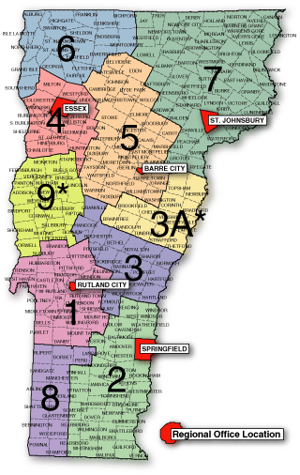
DISTRICTS 1, 8, & 9
450 Asa Bloomer State Office Bldg.
Merchants Row
Rutland, VT 05701-5903
DEC Permit Specialist
786-5907
DEC Wastewater Program
786-5900
Act 250 (Dist #1 & 8)
786-5920
Act 250 (Dist #9)
879-5614
DEC River Management
(Dist #1 & 8)
371-8342
DEC River Management
(Dist #9)
879-5631
DEC Wetlands (Dist #8)
885-8851
DEC Wetlands (Dist #1 & 9)
490-6175

DISTRICTS 2 & 3
100 Mineral Street, Suite #303
Springfield, VT 05156
DEC Permit Specialist
885-8850
DEC Wastewater Program
885-8956
Act 250 (Dist #2, 3, & 3A)
885-8855
DEC River Management
345-3510
DEC Wetlands
885-8851

DISTRICTS 4 & 6
111 West Street
Essex Junction, VT 05452
DEC Permit Specialist
879-5676
DEC Wastewater Program
(Dist #4 & 6)
879-5656
DEC Wastewater Program
(Dist # 9)
786-5900
Act 250 (Dist #4, 6, & 9)
879-5614
DEC River Management
879-5631
DEC Wetlands
490-6176

DISTRICTS 3A & 5
5 Perry Street, Suite 80
Barre, VT 05641
DEC Permit Specialist
476-0195
DEC Wastewater Program
476-0190
Act 250 (Dist #3A)
885-8855
Act 250 (Dist #5)
476-0185
DEC River Management
476-2679
DEC Wetlands (Dist #3A)
490-6175
DEC Wetlands (Dist #5)
490-6178

DISTRICT 7
1229 Portland Street, Suite 201
St. Johnsbury, VT 05819
DEC Permit Specialist (Tues)
751-0127
DEC Permit Specialist
M,W,Th,F
476-0195
DEC Wastewater Program
751-0130
Act 250
751-0120
DEC River Management
751-0129
DEC Wetlands
490-6178

3A* NOTE:
Towns in District 3A must contact the Springfield Office for Act 250 Permits. For Water Supply, Wastewater Disposal and Subdivision Permits, District 3A must contact the Barre Office.
9* NOTE:
Towns in District 9 must contact the Essex Junction Office for Act 250 Permits. For WaterSupply, Wastewater Disposal and Subdivision Permits, District
9 must contact the Rutland Office.

Vermont Land and Water Conservation Fund Map Guidelines

Maps are critical components of your application. The accurate, complete and clear cartographic communication of your project in geographic and political context will allow:
• Ranking Committee to fully understand and fairly assess your project
• Environmental and archaeological clearance reviews to occur efficiently
• Public accessibility
• Perpetual legal protection of the designated 6(f)(3) recreation area

Each project must submit the following maps:
• Geographic Location Map (see table below for required map elements)
• Site Plan Map (see table below for required map elements)
• 6(f)(3) Legal Boundary Map (see table below for required map elements)

Note: The Site Plan Map and the 6(f)(3) Legal Boundary Map may be combined if all components can be cleanly and clearly presented. In this case, the map should be titled, “Site Plan and 6(f)(3) Legal Boundary Map for Project Name.”

It is important to understand the 6(f)(3) Legal Boundary Map is the proposed area to be developed or acquired with LWCF grant money. This area will be protected under Section 6(f)(3) of the LWCF Act, which states that property acquired or developed with LWCF money shall not be converted to uses other than public outdoor recreation. This protection is in perpetuity. The boundary area is sometimes an entire parcel or multiple parcels; other times it may be a portion of a parcel. The recreation area must be capable of providing viable public recreation without reliance on adjoining areas not identified in the project scope. Non-recreational facilities should not be included. For example, a school building, town maintenance building or community center would be excluded along with a sufficient buffer (50 feet) to accommodate potential expansion. Structures directly related to recreation may be included.

Mapmaking Help and Tools:

There are many tools and resources for helping to make a good map. Below is a list taken from the Vermont Center for Geographic Information (VCGI) website (http://vcgi.vermont.gov/).
VCGI also manages the Vermont Interactive Map Viewer, where you can make your own map via an easy online platform. See http://maps.vermont.gov/vcgi/vtmapviewer/ to get started. You can add shapefiles, map layers and download your map in a number of file formats, as well as download all georeference data.
VT State Agencies and Departments:
- VT Health Dept.
- Agency of Natural Resources (ANR) (another great online interactive map viewer, the Natural Resources Atlas, is available here)
- VTrans
- E911
- VT Geodetic Survey

GIS Consultants - This list is voluntary and open to anyone who provides GIS services to people or organizations in Vermont. Contact the Outreach Coordinator if you would like to be added to this list.
Regional Planning Commissions - Each of the 11 RPCs in the state has at least one GIS specialist on staff. These staff members provide GIS expertise to their member towns as well as to support the planning function of the RPC. They are also invaluable resources to schools, nonprofits, and other government agencies working in that region. RPCs are also the best source for local GIS data. The VAPDA web page provides contact information for each of the RPCs.
Academic Institutions - Many of the colleges and universities in Vermont offer GIS classes and programs. We have listed most of them below.
- University of Vermont - Geospatial Technologies Minor
- Middlebury College - Geography Department
- Green Mountain College - Geology Department
- Lyndon State College - Mountain Recreation Management Department
- Johnson State College - search course listings for GIS

Not quite GIS....Are you looking for Census Data? Perhaps the Indicators site that used to be linked from our site? Here is the link to the VT State Data Center, with links to Indicators and other resources: http://www.uvm.edu/crs/Census/
Neighboring States and Provinces
- Connecticut (MAGIC)
- Le Québec Géographique
- Maine (MEGIS)
- Massachusetts (MassGIS)
- New Hampshire (GranitGIS)
- New York (NYS GIS Clearinghouse)
- Rhode Island (RIGIS)
Federal Agencies
- GeoData.gov
- National Geospatial-Intelligence Agnecy (NGA)
- U.S. Census Bureau
- U.S. Department of Transportation - BTS
- U.S. Environmental Protection Agency
- U.S. Geological Survey
- USDA - NRCS: Geospatial Data Gateway
- USDA - NRCS: Vermont
Private Sector
- Free GIS Datasets Listing
Basic Cartographic Elements

• Map Title (see examples under map types)
• Date of Map
• North Arrow
• Appropriate Scale
• Map Legend (specify “existing” vs. “proposed”)

Map Type | Map Elements
Geographic Location Map  (Used to navigate to site within its community and for  environmental and archaeological reviews) | - Basic Cartographic Elements  - Title: “Geographic Location Map for Project Name”  - Roads  - < 100ft contours  - Town/County Boundaries  - Potentially Significant Natural Communities (if known)  - Potentially Significant Archaeological Areas (if known)  - Waterways/bodies  - Prominent Landmarks  - Box with simple directions

Map Type | Map Elements
Site Plan Map  (Used to show a detailed layout  of proposed and existing structures and development) | - Basic Cartographic Elements  - Title: “Site Plan for Project Name”  - Existing and proposed structures and development  - Site amenities  - Roads  - Waterways/bodies

Map Type | Map Elements
6(f)(3) Legend Boundary Map  (Used to provide legal documentation of the protected  recreation area) | - Basic Cartographic Elements  - Title: “6(f)(3) Legal Boundary Map for Project Name”  - Known easements, deed restrictions, interests held by others  - Ownership of parcel boundary  - 6(f)(3) Legal Boundary area  - Sufficient legal references of 6(f)(3) Legal Area Boundary for identification and protection (deed references, adjoining ownerships, adjoining natural water bodies, metes/bounds and/or measurements from permanent locators)  - Measurements for at least some straight boundary lines  - Existing proposed structures and development  - Roads (public access must be clear)  - Waterways/bodies  - Signature box with space for project’s authorized official’s printed name, signature and date.  - Acreage box with number of acreage in the 6(f)(3) Legal  - Boundary Area  - Box with GPS (latitude, longitude) coordinates in degree, minutes, seconds format
Note: The site plan map and the 6(f)(3) Legal Boundary Map may be combined if all components can be cleanly and clearly presented. In this case, the map should be called, “Site Plan and 6(f)(3) Legal Boundary Map for Project Name.”

Sample Legal Descriptions

Boundary Description for Map A
Commencing at an iron pipe set at the southwestern most corner of the property as referenced at Map slide 336 of the town land records thence proceeding N 33 degrees
25'15" W a distance of 80.89 feet to an iron pipe; thence proceeding on a radius equal to
985.00' at a length of 199.24' to an iron pipe; thence proceeding S 60 degrees 05'26" E for a distance of 202.95' to an iron pipe; thence proceeding on a radius equal to 783.00' at a length of 137.76' to an iron pipe; thence proceeding N 76 degrees 24' 10" W at a distance of 2.00' to an iron pipe; thence proceeding S 23 degrees 14'8" W at a distance of 25.76' to an iron pipe; thence proceeding on a radius of 85.00' at a length of 73.82' to an iron pipe; thence proceeding N 72 degrees 59'54" E at a distance of 22.06' to the point or place of beginning.

Signature/Date:

Boundary Description for Map B
Beginning 20 feet from corner #4 of the Boundary Survey Map and continuing northwest
335 feet +/- along the south side of the existing main school building; then turning to the left and continuing a distance of 138 feet +/- toward corner #11; then turning to the left and continuing a distance of 280ft +/- toward corner #12; then continuing in the same direction an additional 20 feet to accommodate for the setback; then turning to the right and continuing a distance of 20 feet toward corner #13; then turning to the left and continuing a distance of 180 feet +/- toward corner #14; then turning to the left and continuing a distance of 125 feet +/- towards corner #2; then turning to the left and continuing a distance of 100 feet +/- towards corner #3; then continuing in the same direction a distance of 320 feet +/- towards corner #4, to the point and place of beginning.

Signature/Date:

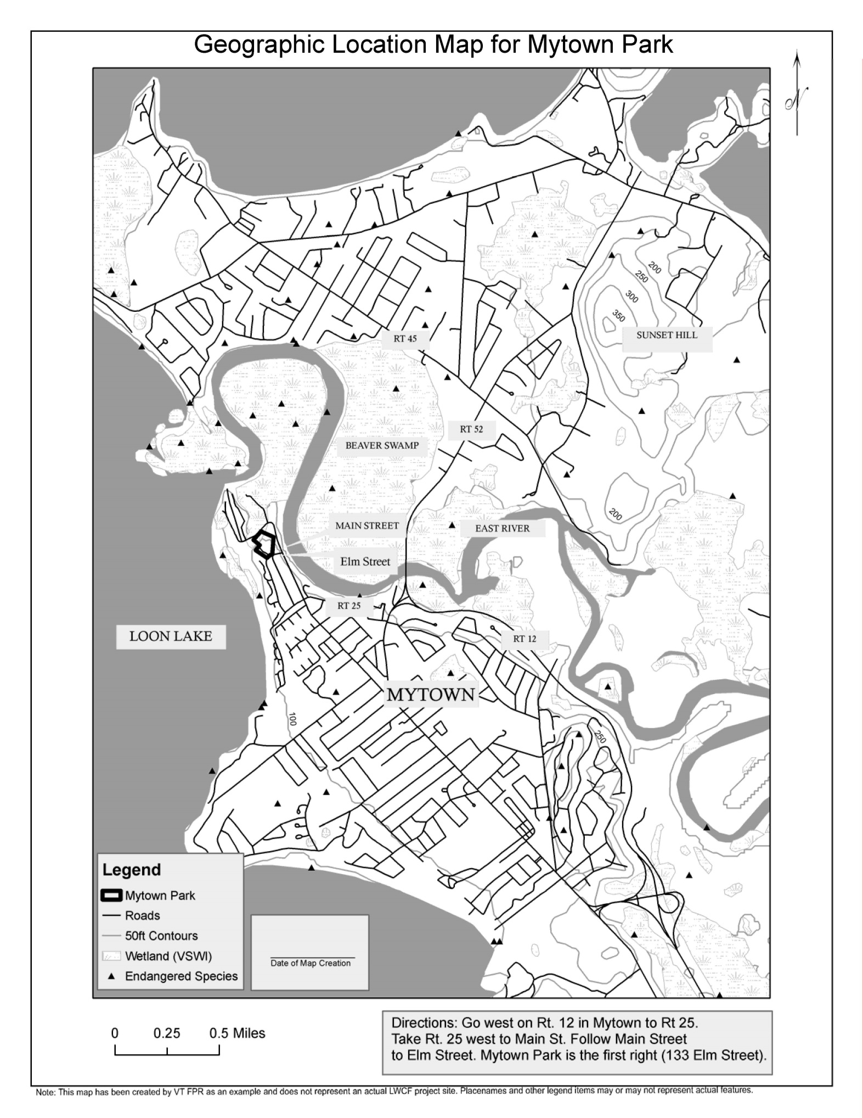
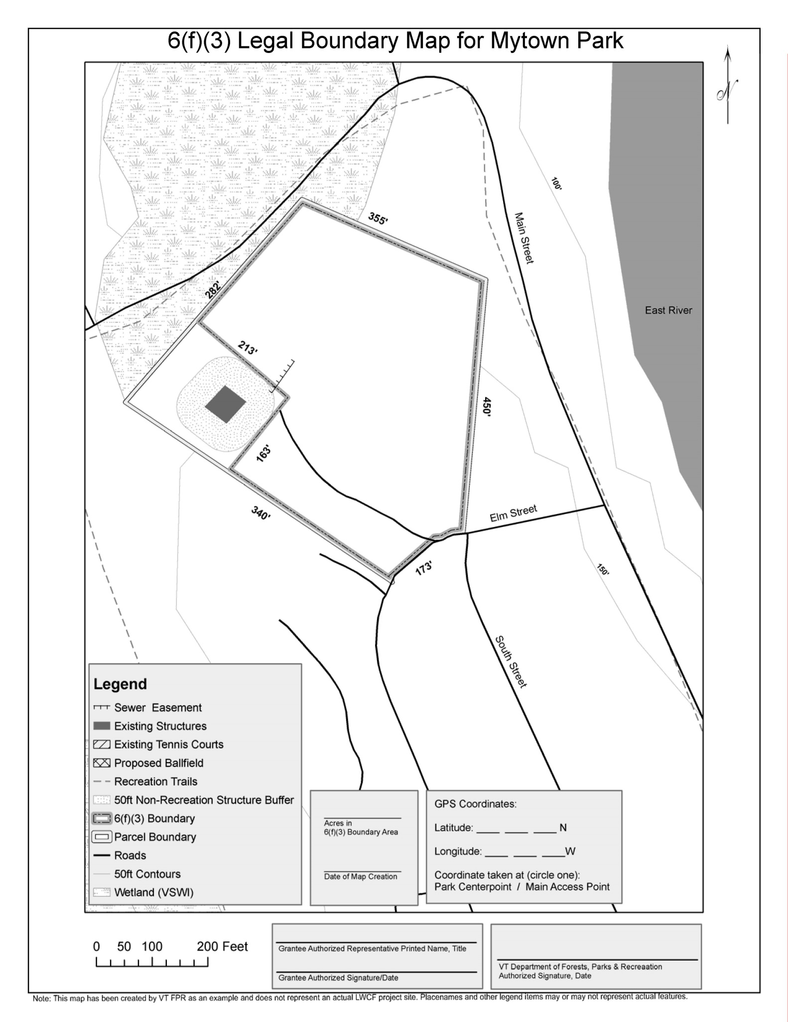
Map Examples:
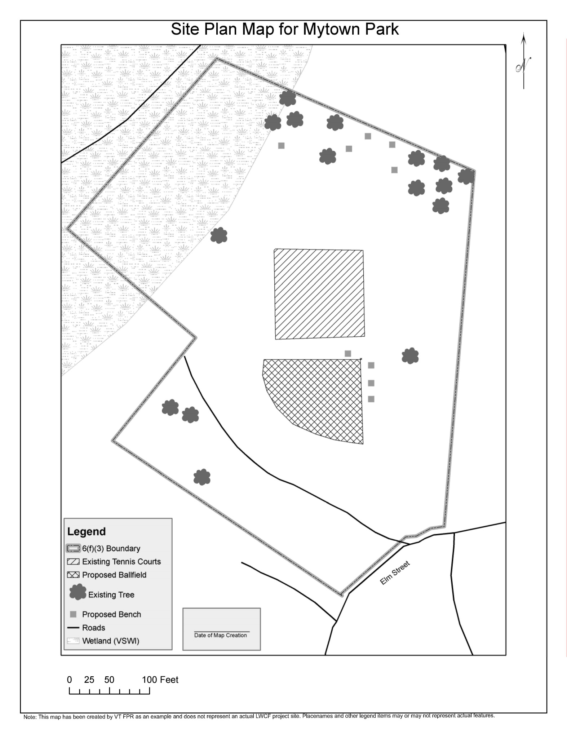

2014-2018 SCORP (Statewide Comprehensive Outdoor Recreation Plan)

Key Findings and Desired Outcomes

The 2014-2018 SCORP fulfills requirements through to the end of the FY 2018 grant application process under the federal Land and Water Conservation Fund (LWCF) Act of
1965 and correlates with the following LWCF grants manual's "Plan Requirements".
This plan identifies outdoor recreation issues of statewide importance, evaluates demand for public outdoor recreation preference, and evaluates the supply of outdoor recreation resources and facilities.

Key Findings pinpoint highest priority needs as identified through analysis of public comments, discussions, and feedback. Using the same method, Desired Outcomes are priority visionary statements of Vermonters’ recreation goals. In accordance with LWCF rules, all projects must explicitly serve a priority identified in the 2014-2018 SCORP. The entire SCORP can be found at www.vtfpr.org.

Key Findings
Outdoor Recreation Priorities
The top five municipal priorities identified in the 2011 Outdoor Recreation Inventory were:
- Parks and open space
- Bike/pedestrian trails
- Baseball/softball fields
- Hiking trails
- Soccer fields

Vermonters responding to the 2011 Outdoor Recreation Demand Survey thought that priority emphasis should be placed on the following recreation facilities:
- Facilities for people with physical disabilities
- Off-leash dog parks
- OHV/ATV trails and roads
- Marinas
- Fishing piers

Staff from the Agency of Natural Resources, user groups, and recreation providers identified the following priority issues that are affecting outdoor recreation in the state:
- Climate change and Other Air Pollution Effects
- State land acquisition priorities
- Hunting and fishing participation issues
- Angler concerns
- Water quality in Vermont lakes
- Recreational access to private land
- State park infrastructure renovation and updating to meet contemporary needs
- Senior-friendly outdoor recreation facilities/resources
- Youth involvement in outdoor recreation
- Trails issues identified by the Vermont Trail Collaborative
- Regulatory jurisdiction for the Statewide Trail System
- Publicly available trails information

Desired Conditions
Desired Conditions
A. All persons who wish to participate in appropriate outdoor recreation activities in Vermont have opportunities to do so.
B. Vermont's natural resources base, including its working rural landscape, which provides the foundation for outdoor recreational pursuits, is conserved, appropriately maintained, properly managed and enhanced.
C. The quality of Vermont's existing outdoor recreation sites, facilities, programming, and operations remains high and adequately satisfies the demand imposed upon it.
D. Vermont meets increasing needs for outdoor recreation by making more resources and diverse opportunities and programming available.
E. Vermont outdoor recreation providers and users develop creative solutions for resolving outdoor recreation challenges and conflicts.
F. The majority of private landowners in Vermont continue to allow access to their land for public outdoor recreation.
G. People pursuing outdoor recreation in Vermont value and appreciate nature and the natural resource base and treat private and public resources and other users with respect.
H. Individuals recreating in Vermont’s outdoors experience health benefits while recreating, and residents of Vermont communities, which emphasize outdoor recreation through their development, become healthier.
I. Information about Vermont's outdoor recreation opportunities is provided in user-friendly ways and directs people to appropriate places.
J. There is strong administrative support for Vermont's outdoor recreation industry by the State of Vermont.
K. Outdoor recreation continues to play a major role and make a significantly important contribution to Vermont’s tourism industry and thus its economy.
L. Vermont considers and addresses the impacts which changing climate has had and will continue to have on outdoor recreation in Vermont.

Financial and Technical Resources
From the LWCF manual, Chapter 5-4:
Federal matching and supplemental programs:
Section 6(f) of the LWCF Act prohibits the use of other federal financial assistance to pay the state or local matching share of a LWCF grant. However, in those instances where the statutory provisions of a subsequent federal grant-in-aid program explicitly allow recipients to use such assistance to match LWCF funds as in Community Development Block Grants (CDBG) and through the Safe, Accountable, Flexible, Efficient Transportation Equity Act: A Legacy for Users (SAFETEA-LU) Act. Section 6(f)(1) of the LWCF Act is superseded and a matching arrangement is permissible.

Additional Financial Resources:

The Vermont Recreation and Parks Association has compiled a list of available grants. See http://www.vrpa.org/grant-opportunities.html for more information.

The Conservation Alliance Grants
A group of 62 outdoor businesses who donate 100% of their membership dues to support grants to grassroots groups for direct citizen action to protect and enhance our natural resources for recreation. You must be nominated by a member first- see website for more details. Contact: John Sterling, P.O. Box 1275, Bend, OR 97709; Phone: 541-389-2424; E-mail: john@conservationalliance.com Website: http://www.conservationalliance.com/grants/how_to_apply

Vermont Housing and Conservation Board Funding (VHCB)
The Vermont Housing and Conservation Board is an independent, state-supported funding agency providing grants, loans and technical assistance to nonprofit organizations, municipalities and state agencies for the development of perpetually affordable housing and for the conservation of important agricultural land, recreational land, natural areas and historic properties in Vermont. Under the VHCB Local Conservation Grant Program, grants of up to $150,000 plus associated costs are available for the purchase and conservation of recreational lands; funds may not be utilized for the construction of recreational facilities. Feasibility funds are also available for predevelopment costs and analysis for individual projects. Conservation applicants may request up to $10,000 per project to compensate contracted services for appraisals, engineering and environmental studies, options, energy assessments and marketing analysis. Contact: Karen Freeman, Director of Conservation Partnerships and Training; 58 East State St., Montpelier, Vermont 05602; 802-828-5067; kfreeman@vhcb.org and www.vhcb.org.

Vermont Division for Historic Preservation Grants Historic Preservation grants are available to assist municipalities and non-profit organizations in restoring important historic buildings; and Certified Local Government matching grants are available for local preservation projects. Contact: Debra Sayers, Division for Historic Preservation, 1 National Life Drive Davis Building, 6th Floor, Montpelier, VT 05620-0501; Phone: 802-828-3213; Email: debra.sayers@vermont.gov Website: http://accd.vermont.gov/strong_communities/preservation/grants

New England Grassroots Environment Fund Small grants of $500 to $2,500 are available to both non- profit and ad hoc groups to increase engagement and participation in grassroots environmental initiatives and to build and connect healthy sustainable communities in New England (including communication needs, capacity building, advocacy campaigns, conferences). Contact: NEGEF, PO Box 1057, Montpelier, VT 05601; Phone: 802-223-4622; Email: info@grassrootsfund.org Website: http://www.grassrootsfund.org

Retired Senior Volunteer Program (RSVP) RSVP is part of Senior Corps, a network of national service programs that provides older Americans the opportunity to apply their life experience to meeting community needs. To learn more how you can tap into a pool of committed volunteers willing to offer their business and professional skills in a diverse range of non-profit organizations, public agencies, and faith-based groups, contact your local Office on Aging Website: http://seniorcorps.gov/

Surplus Property State and local public recreation agencies are eligible to receive federal and state surplus supplies and equipment. Contact: Central Surplus Property Agency, 50 Packard Rd., Suite 2, East Montpelier, VT 05651; Tel: 802-828-3394; Website: http://bgs.vermont.gov/business_services/surplus

Vermont Agency of Transportation (VTRANS): Bicycle and Pedestrian Program
The VT Agency of Transportation (VTrans) works with the states, 11 regional planning commissions and the Chittenden County Metropolitan Planning Organization each year to identify bicycle and pedestrian facility projects (multi-use paths, sidewalks, and rail-trails) that can be funded through the Local Transportation Facilities Program. A 10% local match is required. Early April deadline. Projects must have completed a conceptual alignment analysis or equivalent feasibility study. Contact: Jon Kaplan, Bicycle and Pedestrian Coordinator VTrans, Telephone: (802) 828-0059
E-mail address: Jon.Kaplan@vermont.gov Website: http://vtransengineering.vermont.gov/sections/ltf/bike_ped

Transportation Alternatives
New federal transportation legislation entitled Moving Ahead for Progress in the 21st Century, or MAP-21, was enacted and signed into law on July 6, 2012. One of the programs established in MAP-21 is the Transportation Alternatives Program. It provides for funding opportunities for a variety of project types, many of which were previously eligible under the former Enhancement Program - which Transportation Alternatives in part replaced. The new Transportation Alternatives (TA) Program provides funding for several eligible activities which, as with the Enhancement Program, must demonstrate a strong transportation link. Contact: Scott Robertson; Telephone: (802) 828-5799; Fax: (802) 828-5712; E-mail address: scott.robertson@vermont.gov

Vermont Council on the Arts
Funds are available through the Council’s Grant programs and initiatives for the creation, presentation, and development of cultural arts programming (dance, music, theater, literature, visual arts, etc.). Grant amounts vary but all require at least a 50/50 match. Contact: Sonia Rae, Community Programs Manager, Vermont Council on the Arts, 136 State Street, Drawer 33, Montpelier, VT
05633-6001; Phone: 802-828-5425; Email: Info@vermontartscouncil.org
Website: http://www.vermontartscouncil.org/grants-and-services

The Windham Foundation
Grants are available to support projects that assure the preservation of the rural nature of Vermont, educational activities, other cultural and community projects. Request an application form via phone, mail,fax, or e-mail by contacting: Tuula Ingerson, Grants Administrator; Phone: 802-843-221; FAX: 802-843-2205; Email: windhamgrants@gmail.com; Web site: http://www.windham-foundation.org

Vermont Department of Buildings & General Services
The department makes available Recreational and Educational Facilities Grants to municipalities and nonprofit organizations seeking to make improvements to buildings or purchase equipment for programs.
The grants provide up to $25,000. Applicants must raise three dollars of non-State resources for every one dollar awarded by this program. October deadline. Contact: Judy Bruneau at (802) 828-3519 or (802) 828-33314. Email at Judy.Bruneau@vermont.gov. Grant applications are available at http://www.bgs.vermont.gov

Vermont Recreation Trails Grants
The Recreation Trails Grant Program helps to create and maintain trails and greenways in
Vermont and provides up to 80% of the cost of acquisition, development, and maintenance of recreation trails. Funds are available to municipalities and nonprofit organizations. January 15 deadline. Contact: Sherry Winnie, Grants Administrator, Vermont Department of Forests, Parks and Recreation. Email: sherry.winnie@vermont.gov; Website: http://fpr.vermont.gov/recreation/grants/rtp

